**My Bio**

I’m Nathan, the coffee addict web developer of your dreams! I live in a town called Leighton Buzzard which is part of the Grand Union Canal, the town is most famous for the local quarries used for films like The Mummy Returns and The Da Vinci Code.

Outside of programming I am a creative writer with hopes of becoming a novelist when I’m not busy fixing my parents computer. When I’m not the family’s IT help desk or creating my magnum opus I spend my time reading the news and playing with new technology I can get my hands on!

I am someone who will always go that extra mile to produce the best website possible and can be very competitive in general. So when I’m working on my client’s latest project I will put in the many hours of coffee drinking… I mean coding to get the job done.

# **My Social Media**

A record of my social media accounts.

[](https://twitter.com/NTJMatthews)

@NTJMatthews - [**https://twitter.com/NTJMatthews**](https://twitter.com/NTJMatthews)

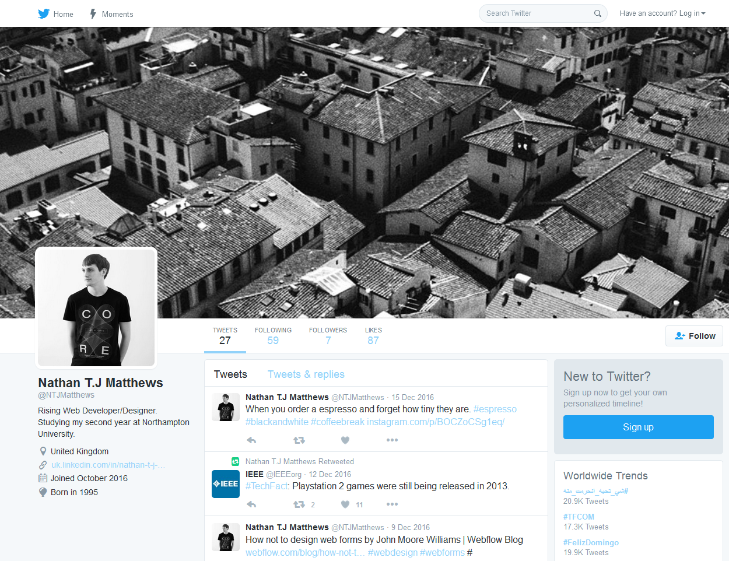

[](https://uk.linkedin.com/in/nathan-t-j-matthews-29909a131)

Nathan T.J Matthews-[**https://uk.linkedin.com/in/nathan-t-j-matthews-29909a131**](https://uk.linkedin.com/in/nathan-t-j-matthews-29909a131)

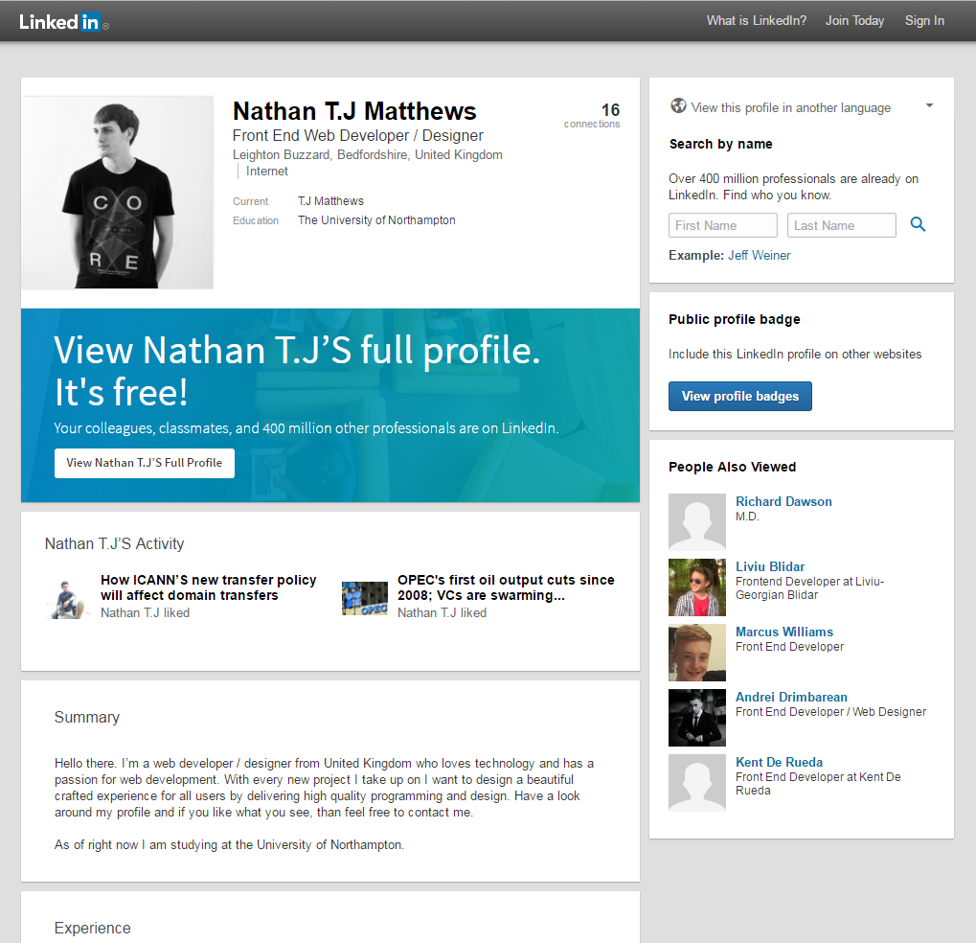

[](https://www.instagram.com/ntjmatthews/)

ntjmatthews-[**https://www.instagram.com/ntjmatthews/**](https://www.instagram.com/ntjmatthews/)

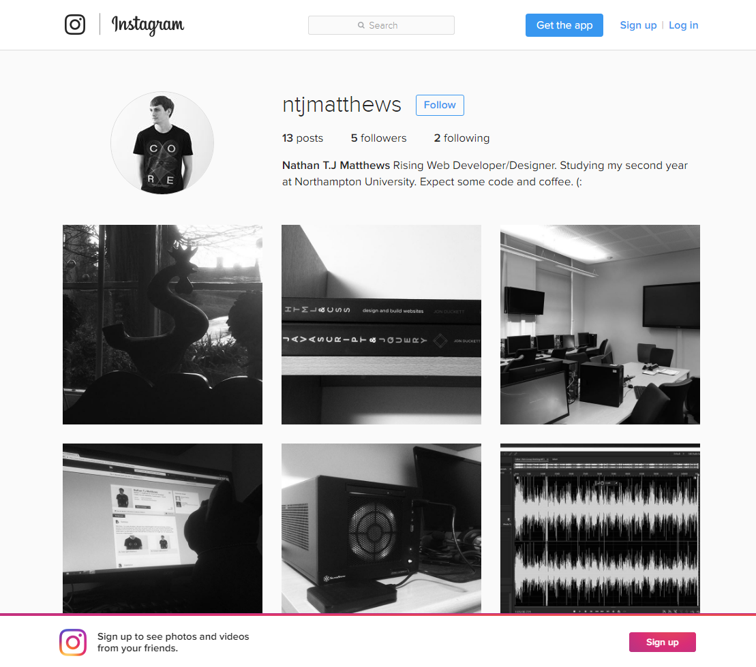

[](https://github.com/nathanterryjohnmatthews)

ntjmatthews **-** [**https://github.com/nathanterryjohnmatthews**](https://github.com/nathanterryjohnmatthews)

